VCOM-10 External Frequency Control/Modulation
- Open VCOM-10 source case.
- Disconnect coaxial connector of SMB type marked as VCO (voltage controlled oscillator).

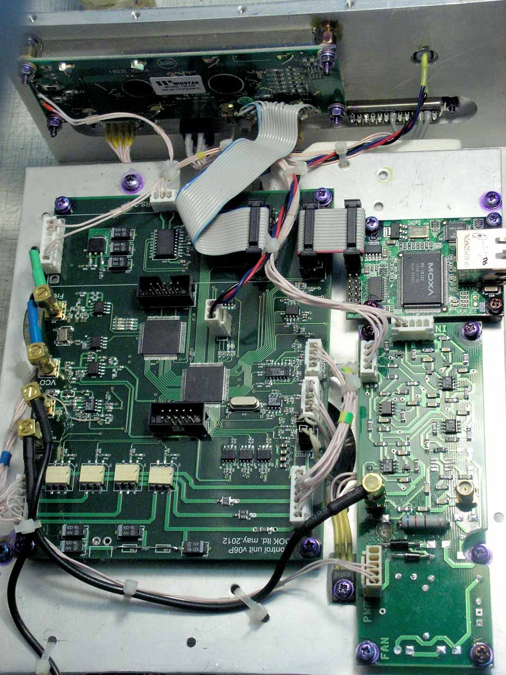

The other side of the coaxial cable is connected to VCO input.

- Control voltage should be applied to SMB, male cable connector disconnected from the control board. Control voltage must be < +23Volt. Negative polarity is prohibited.

- Send commands

@DAF!on# ; frequency stabilization mode is OFF (direct frequency control)
@U27!on# ; switch +27V on
@PWR!xxx# ; set required output power (0mW output power is as default)

Frequency counter measures an average frequency at frequency modulation mode (FM) or current value at DC control

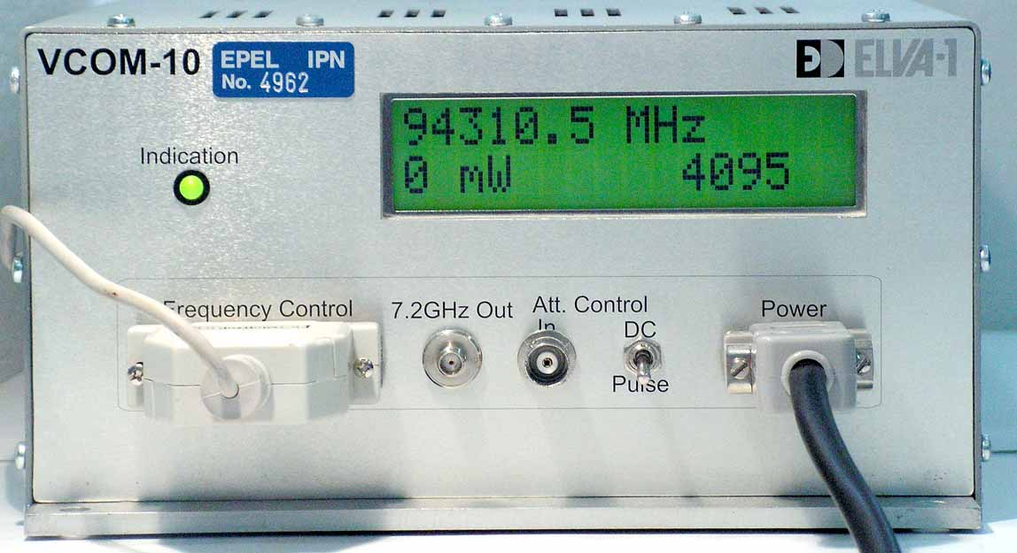
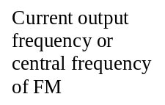
Output power
The 4-figure sign means direct frequency control mode. Does not matter if control cable is disconnected from control board.

ATTENTION! VCO has very high input impedance so it make be damaged by static electricity. Maximal input VCO voltage is 23V.

VCO characteristic is shown at figure below.
